BASAVESHWAR ENGINEERING COLLEGE

(AUTONOMOUS)

BAGALKOTE-587102



DEPARTEMENT OF ELECTRONICS AND COMMUNICATION

CERTIFICATE

This is to certify that assignment project entitled ”QR CODE GENERATOR” a bonified work of Gururaj patarad, Nikhil machaknur. The report satisfies the academic requriments with respect to project work prescribed for the 3rd semester during the academic year 2022-2023.It is certified that all suggestions indicated assessment of the project have been satisfied.

PROJECT GUIDE: HEAD OF THE DEPARTMENT:

PROF. M.C.ARALIMARD DR.SHRIDHAR KUNTOJI

SIGNATURE WITH DATE:

***INTRODUCTION***

A QR (quick response) code is a box-shaped matrix form of a 2-dimensional barcode (also called checkerboard-type barcode) that contains some meaningful data or linkage.

Such a code remains distributed on a 2D plane. It can hold numbers, English alphabets, Japanese letters, Chinese characters, special symbols (**Unicode and ASCII**), binary information, and other information within that square image. The corresponding appearance of dots (**square dots or other shapes**) represents binary "1", and the absence of these dots or white/blank spaces represents binary "0".

**TYPES OF QR CODE  
  
1.**Micro QR code  
  
2.General QR code

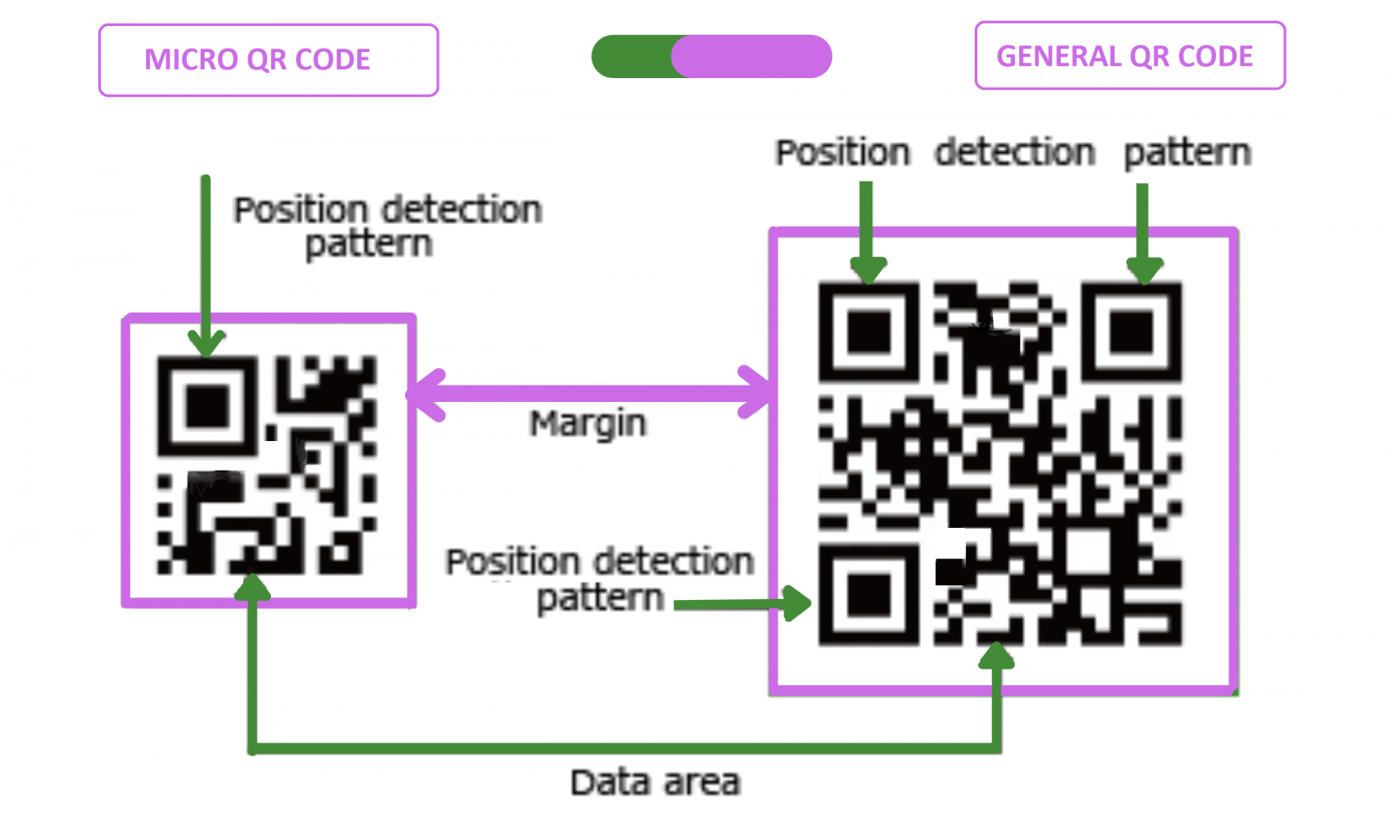

**Steps to build the QR Code Generator in Python**

* 1. Importing the modules
* 2. Creating the main window
* 3. Taking the input of the text/URL, location to store the QR code, name of the QR code and the size of the QR code
* 4. Writing the function to generate and save the QR Code

**Source code**

**!pip install qrcode**

**import qrcode**

**data=”**[**https://www.youtube.com/watch?v=By5DDVXNH-M**](https://www.youtube.com/watch?v=By5DDVXNH-M)**” # paste the link which u want to fit.**

**img = qrcode.make(data)**

**img.save("Qrcode.png")**

**CONCLUSION**

**Among all these modules , the pyqrcode is the most useful one.The second popular is the MyQR module that leverages programmers to generate colour QR or QR blended with images and logos.This makes the module more interesting.But it requires the os module to make it fully functional .So,another efficient module is the qrcode module that renders QR code with less time and space complexity.**